WLAN-2450
2.4/5 GHz Dual-Band Sub-Sampling WLAN Receiver

DESCRIPTION  The WLAN-2450 is a fully integrated dual-band sub-sampling receiver front-end supporting operation in the 2.4 GHz and 5 GHz WLAN bands. The receiver employs a direct RF-to-IF conversion architecture with optimized sub-sampling frequency selection to achieve high receiver performance while reducing analog front-end complexity and power consumption.  The device integrates an active balun low-noise amplifier (LNA), sub-sampling down-conversion mixer, intermediate-frequency (IF) amplifier, and switched-capacitor decimation filter within a single receiver chain. The optimized architecture supports continuously programmable gain and dual-band operation from 2.4 GHz to 5.7 GHz, enabling an error vector magnitude (EVM) of −40 dB over a 19-dB input power range.  Implemented in a 65-nm CMOS process and occupying only 0.72 mm², the WLAN-2450 consumes 55.6 mW from a 1.2-V supply while supporting signal bandwidths of up to 77 MHz. The receiver is ideally suited for IEEE 802.11 WLAN systems, wireless access points, embedded Wi-Fi modules, software-defined radio (SDR) platforms, and other dual-band wireless communication applications. | KEY FEATURES  - Dual-band operation: 2.4 GHz and 5 GHz WLAN  - Direct RF-to-IF sub-sampling receiver architecture  - Active balun low-noise amplifier (LNA)  - Sub-sampling down-conversion mixer  - Switched-capacitor decimation filter with integrated band selection  - Continuously tunable gain: 26–41 dB (2.4 GHz), 26–38.5 dB (5 GHz)  - Continuously tunable 5-GHz band (4.5–5.7 GHz)  - Signal bandwidth: 77 MHz  - Error Vector Magnitude (EVM): −40 dB  - Noise Figure: 11.5 dB  - IIP₃: −8 dBm  - Power consumption: 55.6 mW  - Active area: 0.72 mm² in 65-nm CMOS  - Supply voltage: 1.2 V (core)

APPLICATIONS

Application | Relevant Bands | Notes
Wi-Fi Access Points | 2.4 GHz / 5 GHz | Dual-band WLAN operation
Wireless Client Devices |  | High-performance receiver front-end
  2.4 GHz / 5 GHz
Embedded Wi-Fi Modules | 2.4 GHz / 5 GHz | Compact, low-power integration
Software-Defined Radio (SDR) | 2.4–5.7 GHz | Reconfigurable sub-sampling receiver
Industrial Wireless Networks | 2.4 GHz / 5 GHz | Wideband wireless connectivity

ELECTRICAL SPECIFICATIONS
TA = 27°C, VDD = 1.2 V, unless otherwise noted.

Parameter | Symbol | Min | Typ | Max | Unit | Conditions
RF Frequency Range | f_{RF} | 2.4 | — | 5.7 | GHz | Dual-band operation
IF Frequency | f_{IF} | 445 | — | 538 | MHz | Direct RF-to-IF conversion
Signal Bandwidth | BW | — | 77 | — | MHz | WLAN signal bandwidth
Receiver Gain (2.4 GHz) | G | 26 | — | 41 | dB | Continuously programmable
Receiver Gain (5 GHz) | G | 26 | — | 38.5 | dB | Continuously programmable
Error Vector Magnitude | EVM | — | −40 | — | dB | Over 19-dB input power range
Noise Figure | NF | — | 11.5 | — | dB | Highest gain setting
Input IIP₃ | IIP₃ | — | −8 | — | dBm | Lowest gain setting
Power Consumption | P | — | 55.6 | — | dB | Total receiver power
Active Area |  | — | 0.72 | — | mm² | 65-nm CMOS
Supply Voltage (Core) | VDD | — | 1.2 | — | V | Core supply

POWER CONSUMPTION
Note: Power consumption is identical for both the 2.4 GHz and 5 GHz receive modes.
Block | Power | Supply | Notes
Active Balun LNA | 19.88 mW | 1.2 V | Dual-band low-noise amplification
IF Amplifier | 5.39 mW | 1.2 V | Programmable IF gain stage
Baseband Amplifier | 2.52 mW | 1.2 V | Baseband signal amplification
ARCHITECTURE OVERVIEW
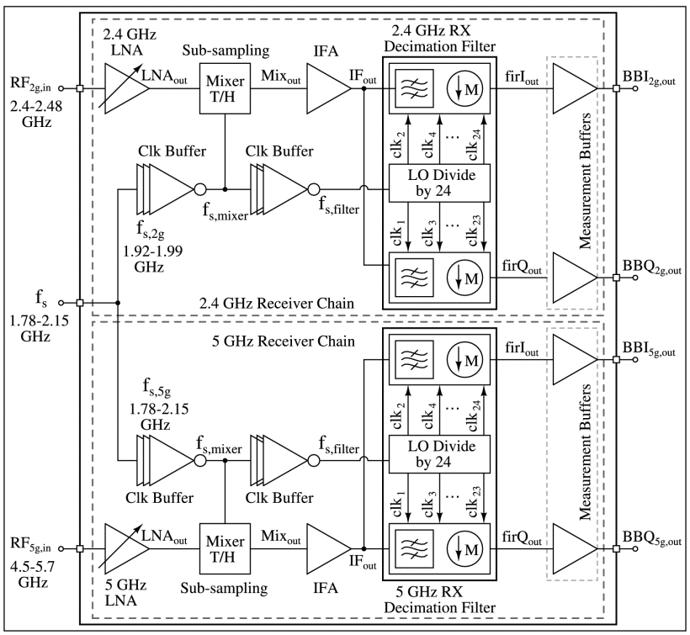

Receiver Signal Path  - Active balun LNA provides low-noise differential RF amplification.  - Sub-sampling mixer performs direct RF-to-IF down-conversion.  - IF amplifier provides continuously programmable receiver gain.  - Switched-capacitor decimation filter performs baseband conversion and channel selection.  - Supports dual-band operation at 2.4 GHz and 5 GHz WLAN bands. | Gain Control & Band Selection  - Continuous receiver gain tuning for improved EVM performance.  - Supports 26–41 dB gain (2.4 GHz) and 26–38.5 dB gain (5 GHz).  - Continuously tunable 5-GHz operating band from 4.5–5.7 GHz  - Optimized sub-sampling frequency minimizes receiver impairments.  - Achieves −40 dB EVM over a 19-dB input power range.
FREQUENCY PLAN

Parameter | Value
RF Frequency (f_{RF}) | 2.4 GHz / 4.5–5.7 GHz
Sampling Frequency (f_{S}) | 1.78–2.15 GHz
Intermediate Frequency (IF) | 445–538 MHz
Signal Bandwidth | 77 MHz
ABSOLUTE MAXIMUM RATINGS
Stress above listed limits may permanently damage the device. Functional operation at these limits is not implied.

Parameter | Limit | Unit
Core Supply Voltage (VDD) | 1.2 + 0.3 | V
I/O / Buffer Supply Voltage | 2.5 + 0.5 | V
Operating Temperature | −40 to +85 | °C
ESD Rating (HBM) | 2000 | V
DEVICE INFORMATION

Parameter | Value
Part Number | WLAN-2450
Technology | 65 nm CMOS (TSMC 1P9M)
Die Size (Active) | 0.72 mm²
Die Supply (Core) | 1.2 V
Die Supply (I/O) | 2.5 V
Package | QFN40
Operating Temperature Range | −40°C to +85°C
DESIGN SUPPORT & RELATED RESOURCES

For more information, visit https://www.linkedin.com/company/chipinsemi/ All product names, logos, and brands are property of their respective owners

